# AI Assisted Coding – Assignment 1.4

Course Code - 24CS002PC215

Course Title - AI Assisted Coding

Year / Sem - II / I ( 2 – 1 )

Regulation - R24

Date : 24-08-2025

Student Name : G.Sanjansah

Hall Ticket Number : 2503a52l20

Student Mail-ID : 2503a52l20@sru.edu.in

# Task 1 :

# Screenshot 1 :

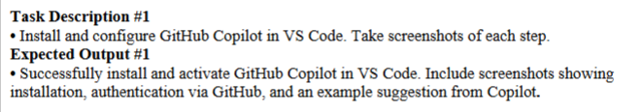

# Screenshot 2 :

# Screenshot 3 :

# Task 2 :

# Screenshot 1 :

# Screenshot 2 :

# Task 3 :

# Screenshot 1 :

# Screenshot 2:

# Task 4 :

# Screenshot 1 :

# Screenshot 2 :

# Task 5 :

# Screenshot 1 :

# Screenshot 2 :

